MASTER ART WORSKHOPS

NEWSLETTER

Welcome to our first newsletter of 2025 and we have an exciting programme to share with you.

We are very pleased to confirm some great artists will be joining us this year and we are providing a variety of art and craft workshops hopefully to suit everyone! We have tried to keep our prices as reasonable as possible and our early 2025 sale will enable some more savings.

We know your time is precious and you book with us in good faith but If we are unable to attain our minimum numbers we will have to cancel the workshop but will keep you informed so you can make alternative arrangements.

If you book and pay before end of February we will offer a 10% discount on all those workshops you book.

To book your favourite workshop email us at via www.masterartworkshops.com or suewilliams021@aol.com

2025 Workshops

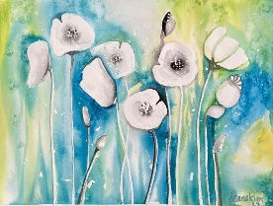 | Saturday 1st March at Dutch Marketplace  Spring Scenes in Watercolour - Deana Kim Page  10am -1pm price £56 lunch included, suitable for all levels
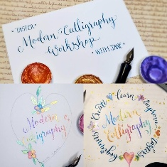 | Saturday 8th March at Little Berkhamsted  Have a Go at Modern Calligraphy - Jane Lappage  10am - 4pm price £80 includes all materials and lunch, suitable for all levels
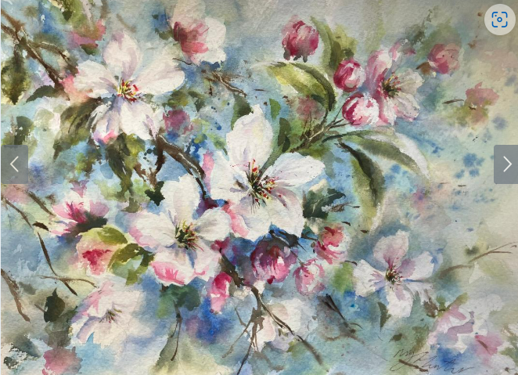 | Saturday 22nd March at Little Berkhamsted  Beautiful Breezy Spring Blossom in Watercolours - Nicky Hunter  10am - 4pm price £85 lunch included, some experience required
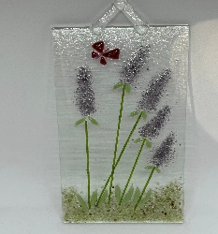 | Saturday 5th April at Little Berkhamsted  Glass Fusion - Laura Brooks-Payne  10am -1pm price £65 no experience required
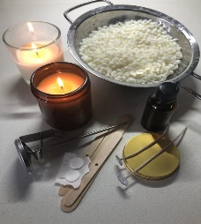 | Saturday 3rd May at Little Berkhamsted  Candle Making - Anne Nudd  10am -1pm price £65 includes all materials, suitable for all levels
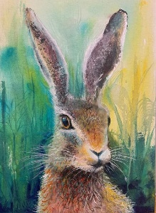 | Sunday 11th May at Epping Golf Course  Hare in Acylics - Deana Kim Page  10am -1pm price £50 all materials included, suitable for all levels
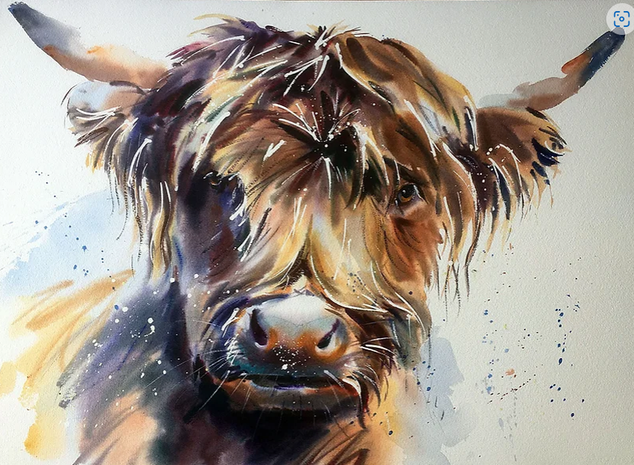 | Saturday 7th June at Little Berkhamsted  Highland Cow in Watercolours - Jake Winkle  10am - 4pm price £90, refreshments and lunch included, suitable for all levels
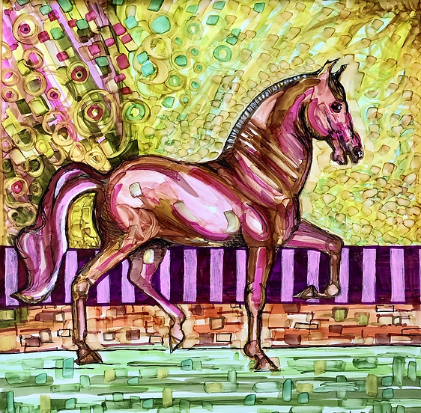 | Sunday 6th July at Epping Golf Course  Pet Portraits in Acrylics - Deana Kim Page  10am - 1pm price £50 all materials included suitable for all levels
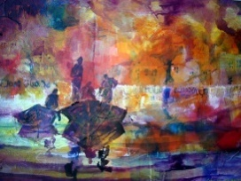 | Saturday 12th July at Little Berkhamsted  Mixed Media with Acrylics - Sera Knight  10-4pm price £85 lunch included, suitable for all levels
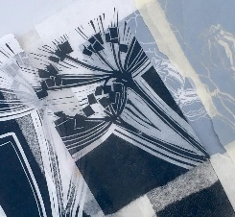 | Saturday 26th July at little Berkhamsted  Lino Cutting and Printing - Jackie Devereux  10am - 4pm price £85 all materials and lunch included, suitable for all levels
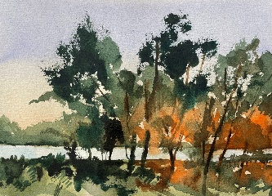 | Sunday 3rd August at Epping Golf Course  Landscape in Watercolours - Frank Walters  10am - 4pm price £90 includes lunch, suitable for all levels
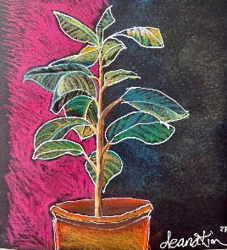 | Saturday 9th August at Dutch Marketplace  Flowers or Sculptures in Pastels - Deana Kim Page  10am -1pm price £56 all materials and lunch included, suitable for all levels
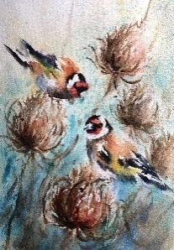 | Saturday 20th September at Little Berkhamsted  Finches & Teasdels in Watercolours - Nicky Hunter  10am - 4pm price £85 lunch included, some experience required
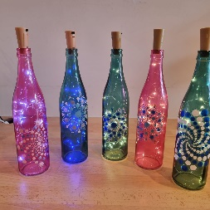 | Sunday 21st September at Epping Golf Course  Mandala Dotting - Angelique Samadhi  10am -1pm price £50 all materials included, suitable for all levels
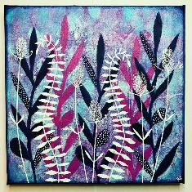 | Sunday 12th October at Epping Golf Course  Gel Printing - Holly Casey  10am -1pm price £50 includes all materials suitable for all levels
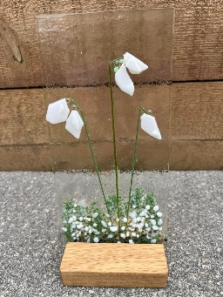 | Saturday 18th October at Little Berkhamsted  Glass Fusion - Laura Brooks-Payne  10am -1pm price £65 all materials included, suitable for all levels
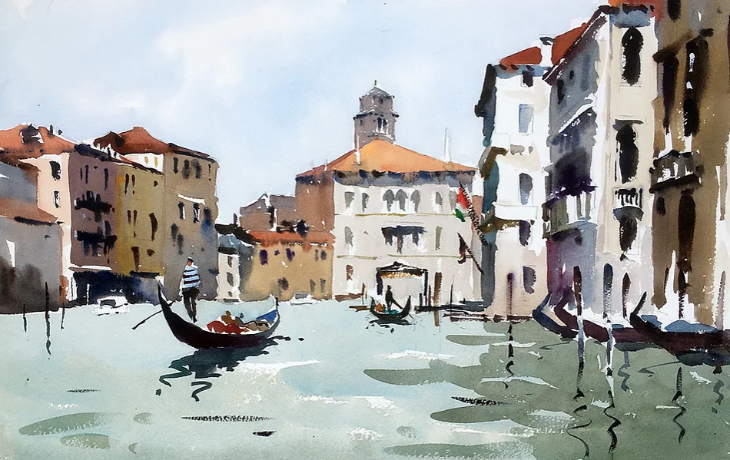 | Saturday 15th November at Little Berkhamsted  People and places in Watercolours - Jake Winkle  10am - 4pm price £90 lunch included, suitable for all levels
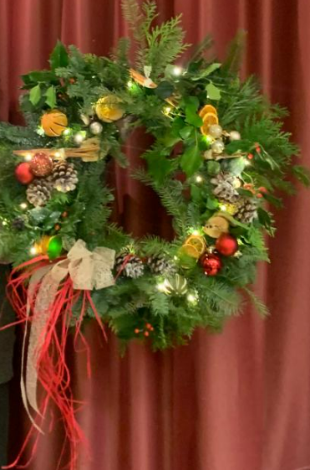 | Wednesday 3rd December at Little Berkhamsted  Luxury Wreath Making - Lorraine Howard  7pm - 9.30pm price TBC, all materials, nibbles and mulled wine included, suitable for all levels

These images are a sample of the artist’s work and a more specific image will be circulated prior to the workshop where possible.

We will be adding more workshops and may have to alter some of the dates, so do keep an eye on our website, http://www.masterartworkshops.com, for full information and up to date changes.

Our full day workshops include a two course lunch, with tea and coffee available all day. Half day workshops include welcome refreshments & cake
- Little Berkhamsted workshops take place at Little Berkhamsted Village Hall, SG13 8LY.
- Dutch Marketplace at Great North Road, Hatfield AL9 6ND
- Epping workshops take place at the first floor hall at Epping Golf Course, Flux's Lane, Epping CM16 7PE.

We look forward to seeing you soon.

Kind regards
Sue and Judith

Follow us on social media to keep up with our news -
Facebook page is
http://www.facebook.com/masterartworkshops
and instagram page is @masterartworkshops

